##
What it does | What it might be called
Schoology | "Schoology" or "Home | Schoology"
Your email | "Mail," "Outlook," or "Outlook Mail"
Your calendar | "Calendar" or "Outlook Calendar"
The portal  Clever | "Portal," "Portal - GOAL High School”  Resources
##
Here's what a classroom looks like inside: =
Here's what the inside of a virtual classroom looks like before there is anything in the class. When you open yours, the classroom will look the same, but you will have material in it – lessons, videos, assignments, etc.

Yours will look almost exactly like this. If there are small differences, that's fine. =
Yours may look almost exactly like this, but if there are small differences, that's fine.

EM DASH MITIGATION 🙁
Nothing here is a test of whether you're good enough to be here. You're already here. These are just the few things that, if you do them, make everything else easier — and if you don't do them, I can't reach you to help.
=
Nothing here is a test of whether you're good enough to be here. You're already here. These are just the few things that, if you do them, make everything else easier…

…and if you don't do them, I can't reach you to help.

“Any time between 12:01 AM and noon

How to reach me
Best way
Microsoft Teams
Bernard Balizet
Text
719-761-2619
Also fine for calls, 8 AM–noon
Email
b.balizet@goalac.org
“

Slight difference if you can reword it well. The only call prohibition that ends at noon is that from 8 - noon you can call for attendance, and after noon I’ll be calling you. But you can always call me from 8 - 4, and, in fact, you can call other times as well and leave a message.

And I love ever forward, but let’s limit it to card 25 and the spot in card three where I put it now.
Also your “crucial” changes are perfect. We’ll keep those.

EM dash mitigation plus edits

A Regular Day at GOAL
Written for
Sample Student
A walkthrough of what a school day actually looks like — one step at a time.
Use the arrows below, or your keyboard's ← → keys. Tap Contents up top to jump around.
=

A Regular Day at GOAL

A walkthrough of what a school day actually looks like, one step at a time.
Use the arrows below, or your keyboard's ← → keys. Tap Contents up top to jump around.

What three to four hours looks like
GOAL asks for about three to four hours of school work a day. That's the number. How you get there is up to you.
Some people work best in one long stretch. Some people need to break it up. Both are fine. Here are real schedules that work:
- Work 8:00 to noon, straight through.
- Work 30 minutes, break 15 minutes, work 30 minutes, then lunch. Repeat.
- Work an hour, take an hour walk, work an hour, nap, then work two hours.
- Work one hour at 8:00, one at noon, and two at 9:00 at night.
- If you have a job, do two hours before a shift and two after.
- Work 9:00 at night to midnight, then an hour the next morning.
You know yourself better than I do. The only rule is be honest with yourself. "I work better at night" is a real thing. "I'll do it later" every single day is not the same thing, and you already know the difference.
Just make it add up.
For the rest of this walkthrough
Let's pretend you're working 8:00 to noon with no breaks. Not because that's the best way — just so we can walk through the programs in order.
=

What three to four hours looks like
GOAL asks for about three to four hours of school work a day. That's the number. How you get there is up to you.
Some people work best in one long stretch. Some people need to break it up. Both are fine. Here are real schedules that work:
- Work 8:00 to noon, straight through OR
- Work 30 minutes, break 15 minutes, work 30 minutes, then lunch. Repeat. OR
- Work an hour, take an hour walk, work an hour, nap, then work two hours. OR
- Work one hour at 8:00, one at noon, and two at 9:00 at night. OR
- If you have a job, do two hours before a shift and two after. OR
- Work 9:00 at night to midnight, then an hour the next morning. OR
- Some other set up.
You know yourself better than I do. The only rule is be honest with yourself. "I work better at night" is a real thing. "I'll do it later" every single day is not the same thing, and you already know the difference.
Just make it add up. Just put in the time and make it add up. Ever forward.
For the rest of this walkthrough
For for this walkthrough, let's pretend you're working 8:00 to noon with no breaks. Not because that's the best way, but just so we can walk through the programs in order.
OOPS Let me upload a new picture for card 10/25 that has better redactions

Check your messages before anything else
This is the first real task of the day. Before you open a single assignment, check two places:
1. Teams. This is the best way to reach me and the best way for me to reach you.
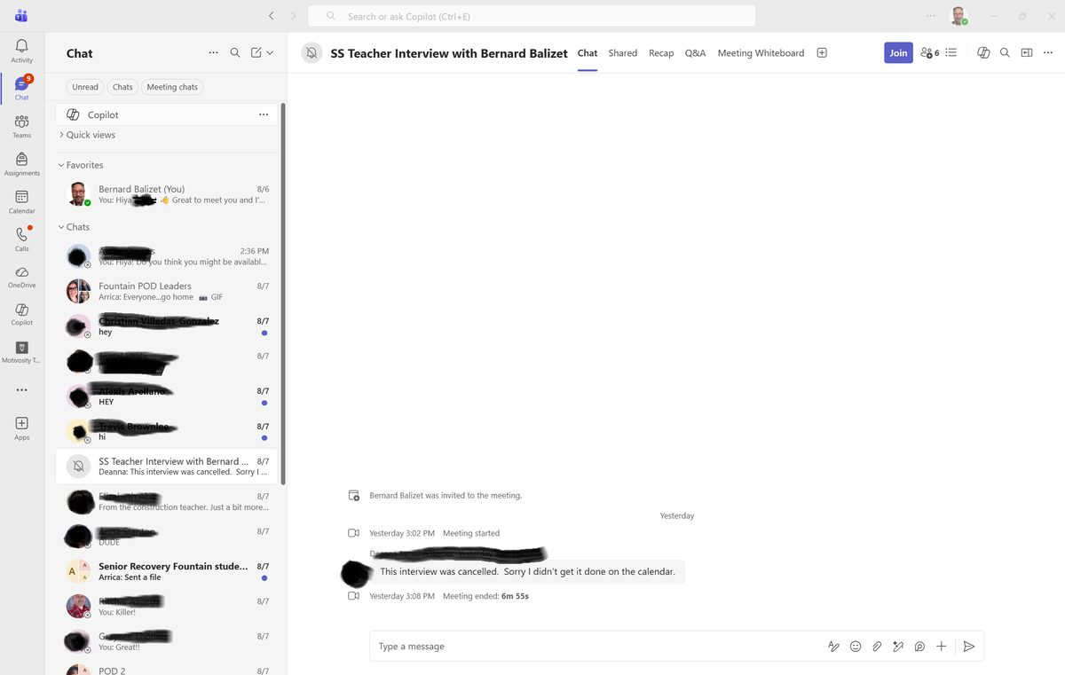 Your chats run down the left side. Click a name, type at the bottom, hit send.
2. Your email (Outlook). Also glance at your texts — I might have sent you one.
Do this first. Every day. It takes two minutes and it means you never miss something that changes your whole plan for the day.
=

Check your messages before anything else
This is the first real task of the day. Before you open a single assignment, check three places:
1. Teams. This is the best way to reach me and the best way for me to reach you.
NEW IMAGE

Your chats run down the left side. Click a name, type at the bottom, hit send.
2. Your email (Outlook).
3. Your texts (if you use phone texts)
Do this first. Every day. It takes two minutes and it means you never miss something that changes your whole plan for the day.

Schoology is your home base. Almost everything starts there.
Open Edge and look at your bookmark bar — the row of links just under the address bar. Schoology should be sitting right there.
=
Schoology is your home base. Almost everything starts there.
Open Edge and look at your bookmark bar: the row of links just under the address bar. Schoology should be sitting right there.
“Click it and see where it goes — that's the fastest way to find out.” We’ll keep this em dash.

Start with the first class in the upper left. Or start with whichever one looks most interesting — that's allowed. Skip Homeroom for now; there usually isn't much in it.
Here's what a classroom looks like inside:
=

Start with the first class in the upper left. Or start with whichever one looks most interesting. That's allowed. Skip Homeroom for now; there usually isn't much in it.
Here's what a classroom looks like inside:

“Read it early — it answers most of the questions you'd otherwise have to ask.” we’ll keep this one

The Grades tab isn't bad. It's genuinely useful for seeing what you're missing.
But here's the trap: Grades can link you straight to an assignment and skip right past the lesson that teaches it. Students land on a quiz, think "I have no idea what any of this is, I must be terrible at this class," and get discouraged when really it’s just that they just never got shown the lesson.
That's not you being bad at school. That's a link taking a shortcut.
So: use Grades to find out what's missing. Then go back to Materials and get to it from there, in order.

Top to bottom. Don't jump ahead.
There's usually a rhythm to it: lesson → assignment → quiz or test. The lessons teach you the thing. The assignments and quizzes check that you got it. If you skip the first part, the second part feels impossible for no good reason.
You can move faster than the schedule if the class lets you. And if you fall behind, you can catch up — late work usually has little or no penalty. Just don't hop around.
=

Top to bottom. Don't jump ahead.
There's usually a rhythm to it: lesson → assignment → quiz or test ) although sometimes the lessons are in the assignments – you’ll get used to it).
The lessons teach you the thing. The assignments and quizzes check that you got it. So if you skip the first part, the second part feels impossible for no good reason.
You can move faster than the schedule if the class lets you, and most of them do. And, crucially, if you fall behind, you can catch up. “Late” work usually has little or no penalty at goal, so don’t hop around trying to skip stuff because you want to catch up or because you believe that you already know the material.
(This doesn’t mean that you should let yourself fall behind, but it does mean that if you are behind there is no reason to avoid pushing forward)
(CLAUDE that last part maybe should be in a new card but one that is only new because it gets added to the previous. That is, when the student hits “next” all of the card’s text stays, but that parenthetical shows up.)

Your first day job: just look
On day one, you don't have to finish anything.
Open each class and read the introductory stuff. Ask yourself:
- What's my teacher's name?
- What programs does this class use besides Schoology?
- Are there any introductory videos?
- How do I contact this teacher?
- Is there a syllabus quiz?
- Is there anything here I don't understand?
If the answer to that last one is yes then please message me. I know I sound like a broken record, but that’s what I’m here for, y’all.

Your teacher will tell you if you need one, usually right at the start, and they'll tell you how to get in. If you follow their directions and still can't get in, message them — or message me and we'll do it together.
Here's why this matters so much:
I can see your Schoology work. I can't see Edmentum.
In Schoology I can watch your progress lesson by lesson and tell when you're moving. In Edmentum and the others, I'm blind. I can't tell if you've logged in once or never.
So a student can be working hard in Edmentum and, from where I'm sitting, look like they've vanished. That's the only reason this is a big deal — not because it's hard, but because I can't help you if I can't see you.
Get logged into those programs early. That's it. That's the whole ask. And if Edmentum has a schedule built in, follow it in order, same as Schoology.
=

Your teacher will tell you if you need one, usually right at the start, and they'll tell you how to get in. If you follow their directions and still can't get in, message them — or message me and we'll do it together.
Here's why this matters so much:
I can see your Schoology work. I can't see into Edmentum.
In Schoology I can watch your progress lesson by lesson and tell when you're moving. In Edmentum and the others, I'm blind. I can't tell if you've logged in once or never.
So a student can be working hard in Edmentum and, from where I'm sitting, look like they've vanished. Or worse, a student might not have been able to get into Edmentum, and I just can’t tell from where I’m sitting.

That's the only reason this is a big deal. It’s not because it's hard, but because I can't help you if I can't see you.
Get logged into those programs early. That's it.
And if Edmentum has a schedule built in, follow it in order, same as Schoology.

Attendance: how to get counted
This is simpler than it sounds.
Reach out to me any day between 12:01 AM and noon, and that day counts.
One minute after midnight through noon. Any of these work:
- Teams — best by far
- Email — b.balizet@goalac.org
- Text — 719-761-2619
- Phone call — 8:00 AM to noon
Teams is the best one. But all of them count.
What about the afternoon? If you reach out in the afternoon, it still counts — I'm not going to turn you away. But after noon, I start looking for you. And when I go looking, I start with your parent or guardian before I come to you.
That's not a threat. It's just the order I'm required to go in. Which is exactly why it's better for you to reach out first. Send me a "hey" on Teams at 9 AM and none of that ever happens.
=

Attendance: how to get counted
This is simpler than it sounds.
Reach out to me any day between 12:01 AM and noon, and that day counts.
One minute after midnight through noon. Any of these work:
- Teams — best by far
- Email — b.balizet@goalac.org
- Text — 719-761-2619
- Phone call — 8:00 AM to noon
Teams is the best one. But all of them count.
What about the afternoon? If you reach out in the afternoon, it still counts. I mean… I'm not going to turn you away for attendance, for heaven’s sake. But the thing is, after noon, I start looking for you. And when I go looking, I start with your parent or guardian before I come to you.
That's not a threat. It's just the order I'm required to go in. Which is exactly why it's better for you to reach out first. Send me a "hey" on Teams at 9 AM and none of that ever happens.

A quick caveat about those grades
(A caveat, by the way, is like a warning. It's like saying “This, yes, AND you should know this other thing too.”)
At any rate, a quick caveat about those grades:
The grades shown are a good baseline, but they aren't always 100% accurate. Some assignments might not have been entered yet, and some platforms like Edmentum and ALEKS don't always show up in the grades right away.
If the grades look roughly where you think they should be? Fantastic.
If some grades look wildly off, however, feel free to reach out to the teacher to verify everything you've turned in is there.
How to ask a teacher about a grade
Please don't open with "why is my grade so low" or anything that sounds like "hurry up and grade my paper." Instead:
First, go back into what you know you've submitted and check whether there's a record of it in your grades or a confirmation in Schoology.
Then reach out to the teacher and ask about a specific assignment.

Transportation
We offer transportation to and from the Fountain site on Mondays and Wednesdays.
- Text or Teams message me by 8:30 AM on the morning you need a ride
- Have at least five assignments planned for the day you're coming in
- I need to approve your request
If you don't confirm by 8:30, we can't guarantee a ride — so please plan ahead and reach out early.

=

Transportation
We offer transportation to and from the Fountain site on Mondays and Wednesdays. You can use this service once or twice a year, you can use it every single day it’s available, or you might never use it at all. All of these choices are legit.
- Let me know if you’re ever interested in transportation, and I’ll put you into our transportation group. It’s not signing your name in stone, it just makes it easier for us to put you into the pick-up mix if and when you decide you need a ride.
- Text or Teams message me by 8:30 AM on the morning you need a ride
- Have at least five assignments planned for the day you're coming in
- I need to approve your request
If you don't confirm by 8:30, we can't give a ride, I’m afraid, so please plan ahead and reach out early.

Last thing
I've used the word crucial a few times here. I want to be clear about what I mean by it.
Crucial means this is the part that matters most. It does not mean panic. It does not mean you'd better not mess this up.
Nothing here is a test of whether you're good enough to be here. You're already here. These are just the few things that, if you do them, make everything else easier.
And, crucially, if you don't do them, I can't reach you to help. And that;s all I want to do. That’s what I’m here for: I’m here to help and I’m here to drink coffee.
But mostly help.
Because here’s the thing: You are going to get confused about something. You're going to click the wrong link, miss an assignment, or open a quiz you weren't ready for. All of that is normal and all of it is fixable.
There is no version of this where you do something so wrong that the right answer is to give up.
So: open the computer. Check Teams. Open Schoology. Open one class.
That's the whole first day.
Ever forward. You got this.

